DIRECT MODELLING:

|  |  |  |  |
| --- | --- | --- | --- |
| Models | RMSE | MAD | Iterations to converge |
| Model 1 | 0.0160 | 1.8910 | 6382 |
| Model 2 | 0.0080 | 1.7903 | 5804 |
| Model 3 | 0.0072 | 0.5488 | 5442 |
| Model 4 | 0.0048 | 0.3834 | 3151 |

With input=exp(-x)

|  |  |  |  |
| --- | --- | --- | --- |
| MODELS | RMSE | MAD | Iterations to converge |
| Model 5 | 0.0084 | 0.2067 | 387 |
| Model 6 | 0.0049 | 0.0965 | 53 |

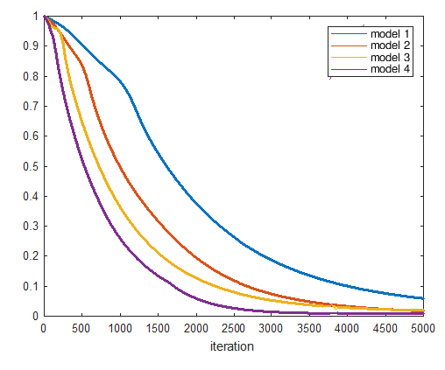

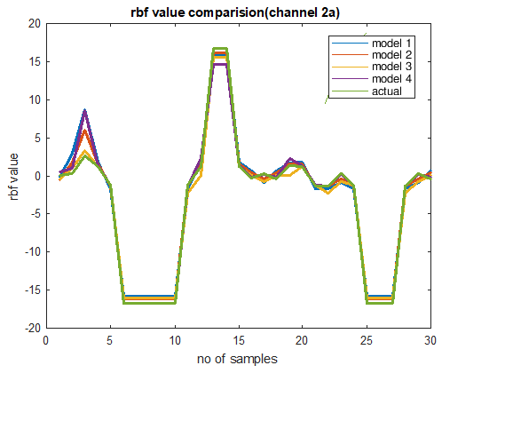

With input exp(-x)

